**Mid-West Regional State Tax Seminar Being Held Jointly with the Chicago Tax Club  
Chicago, Illinois  
May 4, 2022  
May 12, 2015**

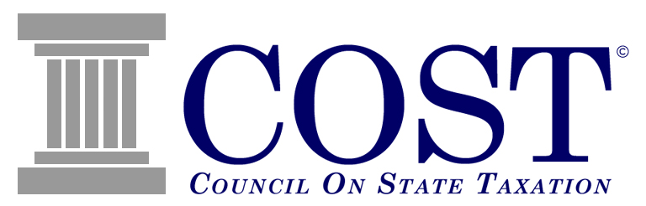

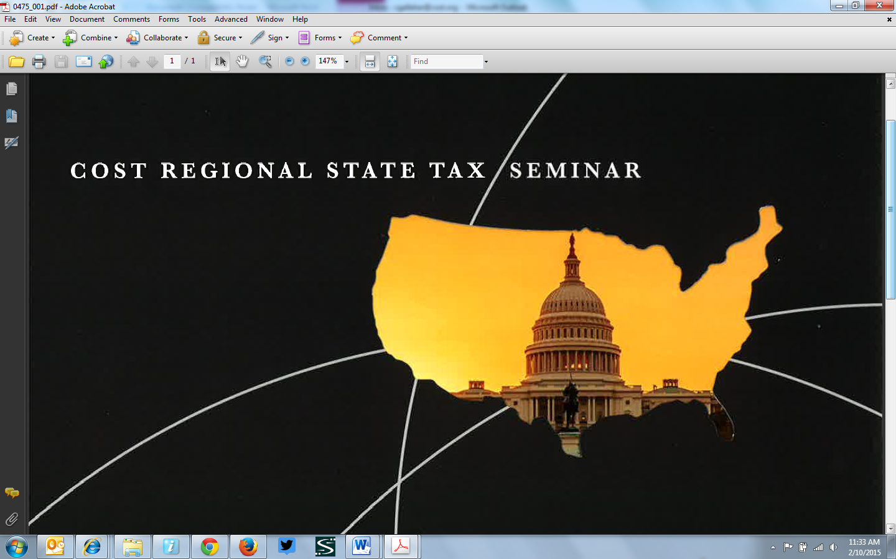

**Presenting an update on significant state tax issues with an emphasis on the Mid-West States:** Illinois, Indiana, Iowa, Kansas, Kentucky, Michigan, Minnesota, Missouri, Nebraska, Ohio and Wisconsin

**Great opportunity to network with your Chicago and surrounding area state and local tax peers.**

**CPE/CLE Available**

**Location:  
Meridian Banquet & Conference Center**1701 Algonquin Road  
Rolling Meadows, IL 60008  
(847) 952-8181  
*(see below for directions)*

**Agenda:**

**Wednesday, May 4, 2022**[**(Click Here To Add To Your Calendar)**](http://www.facebook.com/?ref=home#!/http://cst.informz.net/z/dmNhbC5hc3A_dj05ODkmdWlkPTEwMDA2MjA4Mzc/index.html)

8:00 am – 8:45 am Registration/ Networking /  
Continental Breakfast  
8:45 am – 1:00 pm Program and Discussion  
1:00 pm – 2:15 pm Lunch with Speaker  
2:15 pm – 3:15 pm Open Discussion / Networking

**Sponsored By:**

`

**Registration Information:**



**Registration Fee:**

Chicago Tax Club & COST Member Company Registrant - **$35.00**  
Non- Member Registrant - **$70.00**

**Agenda Topics:   
  
Welcome & Introductions**  
*Charles Drury*, COST  
*Darren Lebiecki*, The Kraft Heinz Company/Chicago Tax Club

**National Legislation and State Tax Policy Matters Update with a Focus on Illinois, Indiana, Michigan, Ohio and Wisconsin**  
*This session will cover significant recent state tax legislative, regulatory and policy developments across the country, but with special attention to the Midwest states.*  
*Sean Evans*, DuCharme, McMillen & Associates, Inc.

*Brandon Freyberger*, DuCharme, McMillen & Associates, Inc.  
*W. Matt McCord*, DuCharme, McMillen & Associates, Inc

**National Judicial Update and Discussion of State Tax Cases**

*Hear the speakers debate and discuss the leading state tax issues in litigation around the country and what the litigation means to your company. .*

*Karl Frieden,* COST

*David Machemer*, HMB Legal Counsel

*Marilyn Wethekam*, HMB Legal Counsel

**Audit Management (including Exemption Certificate Management)**

*This session will cover best practices for managing audits. The speakers will also cover management of exemption certificates.*

*Sean Evans*, DuCharme, McMillen & Associates, Inc.

*Brandon Freyberger*, DuCharme, McMillen & Associates, Inc.  
*W. Matt McCord*, DuCharme, McMillen & Associates, Inc

**PL 86-272 - A Temporary Law Turns 63**

*A discussion of the application of P.L. 86-272 concepts in a global economy. The session will discuss the implications of the Multistate Tax Commission’s revisions to its P.L. 86-272 statement.*

*David Hughes*, HMB Legal Counsel

*Dakota Newton*, HMB Legal Counsel

**Lunch [ADD TOPIC, TOPIC DESCRIPION AND SPEAKER NAME]**

**Additional Information:**

* This seminar is open to members of the Chicago Tax Club, members of COST and other tax professionals from non-member companies.
* Please note that pre-registration ends on May 2nd; thereafter, only cash/checks will be accepted on the day of the meeting for the registration fee..
* Dress for the meeting is business appropriate.
* CLE/CPE credit available.

For more information, please contact [**Tiffany Frazier**](mailto:tfrazier@cost.org)**,** (202) 484-5225 or Denise Obrochta (847) 527-4654.  
  
Follow COST on Twitter.Twitter-Icon.png

**Directions:**

**To access Turn-By-Turn Directions direct from Mapquest, click here.**

Click on Get Directions and then enter your Starting Location.  
  
**Directions to Meridian Banquet & Conference Center, 1701 Algonquin Road, Rolling Meadows, Illinois** –  
  
**From Northeast:** Take Lake Cook, Dundee Rd, or Willow/Palataine Rd to Route 53 South; Exit at Algonquin Rd East (Left Turn); Travel East about 1.4 miles; Meridian facility is East of the intersection of Algonquin Rd and New Wilke Rd.  
**From East:** Take Kennedy to Northwest Tollway (I-90); Exit at Arlington Heights Road North (Right Turn); First stop light is Algonquin Rd - Make a Left Turn & travel West on Algonquin Rd for about 1.4 miles to Meridian facility.  
**From Southeast:** Take 355 North to Route 53 North; Exit at Algonquin Rd East (Left Turn); Travel East about 1.4 miles; Meridian facility is East of the intersection of Algonquin Rd & New Wilke Rd.  
**From West:** Take Northwest Tollway (I-90) East; Exit at Arlington Heights Road North (Left Turn); Second stop light is Algonquin Rd - Make a Left Turn & travel West on Algonquin Rd for about 1.4 miles to Meridian facility.

**Parking & Entrance to Meridian Banquet & Conference Center** – There is ample free parking at the Meridian Banquet & Conference Center Parking Lot. After parking, proceed to the main lobby entrance and go to the Chicago Tax Club/COST registration desk.